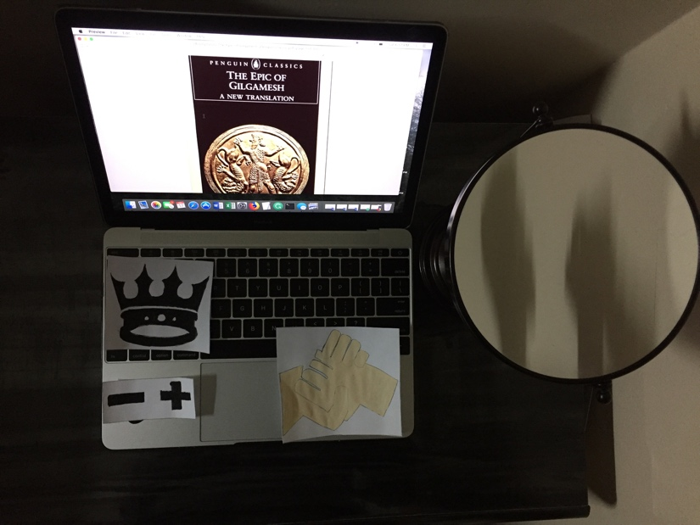

Tuan Nguyen

Book Bento for The Epic of Gilgamesh by Andrew George

The crown

-The crown is a symbol of Gilgamesh, who rules as king in Uruk, a city in Ancient Sumer. He is described as two-thirds of god and one-third human. His cheek was bearded and the hair of his head grew thickly. He is the strongest and handsome man in the city. The people of Uruk emerge Gilgamesh as a kind of cultural hero. He who first dug oases in the desert, crossed the ocean, and discovered the technique of killing the wild bull. Although people of Uruk worship Gilgamesh as the god, they complained that he abuses his power. He has killed his servant without reason and has sexually exploited the young women. His days go by competing in athletic contests with other men in the city. Gilgamesh doesn’t care much about the life of people of Uruk.

Mirror

- The mirror is represented Enkidu, who is formed out of water and clay in the wilderness. Enkidu appears to be another version of Gilgamesh to terminate his assault on the people of Uruk. The god of Aruru heard that people complained about Gilgamesh abuses, so God created Enkidu to be a match for Gilgamesh to control Gilgamesh’s strength. Enkidu has lived a normal life in the wilderness until he meets Shamhat, a temple prostitute of Uruk. His life turns down when he knows that animal in the wild will reject him if he sleeps with a woman.

Handshake

-Handshake represented a friendship between Gilgamesh and Enkidu. They both complimented other strengths. Later, they decided to go on the journey to the forest of Cedar. Their friendships are solid and unbreakable. On the journey to the forest of Cedar, Gilgamesh and Enkidu build a house of the dream God, dig a well, cut down the tree of the forest. Gilgamesh has done awful things in the forest. His most insane thing is to kill Humbaba, the guardian of the forest, to make God angry. However, Gilgamesh doesn’t know that God will kill Enkidu if he slays Humbaba. The dead of Enkidu makes Gilgamesh regrets what he has done on the journey.

Positive and negative sign

The positive and negative sign indicated Gilgamesh successes and failures as a king. Gilgamesh has achieved rebuild the wall of Uruk on its antediluvian foundations, defeat the enemies, and form a wise military all over of Uruk. Gilgamesh is classified as a hero to the people of Uruk, but his talents make him become a brutal ruler. He is obsessed to conquer anything that he finds interest, such as killed Humbaba and innocent servants, raped the young women in the city. Gilgamesh activities make the people of Uruk suffered and despaired to keep up their life.

Computer

-An eBook version of the book.